Food/spice manufacturer was seeking to upgrade the efficiency of their existing air pollution control equipment with a regenerative thermal oxidizer (RTO). During the selection process, it was determined that significant inorganic particulate was present even after extensive 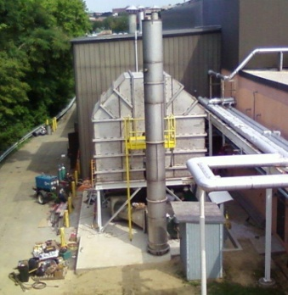pretreatment. This extremely fine particulate presented a potential problem for the RTO in the form of plugging the structured energy recovery modules. The manufacturer hired an independent testing lab to determine if the addition of the two-stage pre-filter was necessary. The testing lab determined the pre-filter was not necessary. However, due to production upsets which could possibly resulted in large amounts of solid particulate ending up in the ceramic media bed, the company decided to go with (belts and spenders) and install the two-stage pre-filter against the recommendation of the test results, so Air-Clear, with their extensive filtration experience, designed a two stage pre-filter which would eliminated the risk of plugging the structured energy recovery modules.

A summary of the Regenerative Thermal Oxidizer equipment includes:

* 20,000 SCFM two-chamber Regenerative Thermal Oxidizer (RTO)
* 304 stainless steel construction
  + Two-stage pre-filter system custom designed for tight space
  + 1st stage – “course” pocket filters – High Load Capacity
  + 2nd stage – “Polishing” HEPA Filtration
* RTO designed for high thermal efficiency/low pressure drop ceramic media to save energy
* PLC Controls interface with Production Management System for seamless system integration
* Designed for future expansion

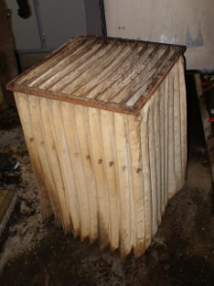 This illustration is of the pre-filter media only after two months of operation, there was a production upset and the pre-filter media was masked with solid particulate. If not for the pre-filter, all of that solid particulate would have ended up in the ceramic media bed. New pre-filter media was installed by Air Clear’s Service Personnel. The successful operation of the RTO would not have been possible without the two-stage pre-filter. The pre-filter system prevented plugging of the ceramic media, therefore increasing the exhaust flow through the unit.